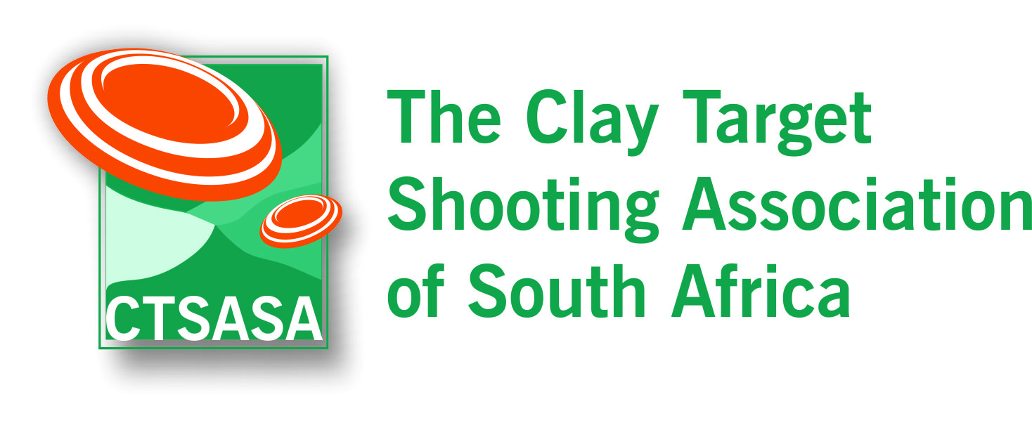

CLAY TARGET SHOOTING
RANGE SAFETY TEST

Safe carrying of shotgun

- Name the two ways in which a shotgun can be carried safely on a shooting range.
- If you have a semi-automatic or pump action shotgun, where should the barrels be pointing when carrying the shotgun?
- Can a shotgun be loaded and placed in a shooting rack?
- May shotguns be closed and placed flat on a table?

Shooting Stand Procedures

- At what point can you load your shotgun when in a squad of shooters?
- Can you point your shotgun at any objects other than a clay target?
- Who has the absolute authority on the shooting range?
- Are you allowed to close your gun while waiting for your turn to enter a shooting stand?

Loading and Firing Procedures

- In what direction should a shotgun be pointing when on a shooting stand?
- What should you do after firing at your targets?
- In the case of a failure to fire, what should you do?
- What is the shot fall safety zone for clay target shot loads?

General Rules

- If you are using snap caps, when can these be inserted into your shotgun?
- When taking a shotgun out of a gun bag, what should be done to the shotgun immediately upon extraction?
- Are gun slings allowed on your gun while shooting clay targets with others on a range?

CLAY TARGET SHOOTING
RANGE SAFETY TEST – ANSWER SHEET

Name: _____________________________

CTSASA No: _____________________________

Date: _____________________________

Q. No. | Answer
1.
2.
3.
4.
5.
6.
7.
8.
9.
10.
11.
12.
13.
14.
15.

