The SafeCitizen Campaign
Building hope for law abiding citizens
MEDIA STATEMENT
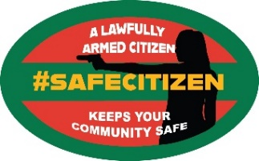
“ THE GOVERNMENT HAS WOKEN A SLEEPING GIANT”

May 25th, 2021 – For Immediate Release
“With the publication of the Firearms Amendment Bill 2021 the Cabinet has woken a sleeping giant. If post 1994, there was ever an event in South Africa close to an ‘Arab Spring’, this is it. In one fell swoop, the Firearm Amendment Bill 2021, has shocked, enraged and frightened South Africans. Approaching this bill from a rational perspective, we can find no justiciation at all within the realm of safety and security for South Africans.” These were the words of Safe Citizen founder, Jonathan Deal, to a Zoom briefing of media and firearms stakeholders yesterday.
The architects of this bill appear to have completely lost touch with rationality as they propose amendments to the current firearm licensing system that are simply unbelievable. Certainly the most bizarre aim of the new bill is to deny citizens the right to possess a firearm for the purpose of self-defence. This comes shortly after Minister Cele is on record in parliament not only reducing the operational budget of the police but concurrently increasing the budget for executive protection of cabinet ministers and political ‘high-ups’.
Deal said: “The drafters of this proposed amendment, display an arrogant, thoughtless and careless attitude towards the public. It is inconceivable that it is in the interest of our citizens to disarm them and leave criminals armed.”
“Civil society, breadwinners, firearms associations and gun owners from every walk of life are uniting in a massive fight against this irrational move by the government. Even if you don’t own a gun now, if this bill becomes law you could forever lose the opportunity to apply for a licence for a self-defence firearm.”
Concerned citizens can join and support us at www.safecitizen.co.za and follow this link to Dear South Africa to register your objection.
https://dearsouthafrica.co.za/firearm-control-2021/

Jonathan Deal
National Coordinator
ENDS
Jonathan Deal – 076-838-5150 – or on WhatsApp or jonathan.deal@safecitizen.co.za

